1. Entry to Gachon University On-campus Housing

★ (Website (Korean Only): https://www.dormitory.ac.kr)
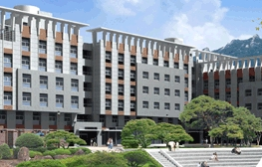

★ Housing Application for International Students

1) Exchange Students can reserve accommodation by submitting the dormitory registration form when submitting the exchange student application materials.

2) To the exchange students who will get waived the dormitory fee, waiver basis of the dormitory is ‘Quad Room (4 Sharing)’. So, the students who want to stay ‘Single’ or ‘Double’ or ‘Triple’ room will be charged the ‘room type’ fee difference.

3) The exchange students who have to pay dormitory fees by themselves, the fees will be charged on the period and time stayed basis following the schedules of the exchange students.

2. Housing Fees * Meals are not included
(These fees are accurate as of 2019. This may change without prior notice)

(Unit: Korean Won)
Classification |  |  | Double | Triple | Quad
For four  (4) months | Deposit |  | 100,000 | 100,000 | 100,000
For four  (4) months | Room  Fee | Rent | 1,180,000 | 956,000 | 732,000
For four  (4) months | Room  Fee | Internet | 26,400 | 26,400 | 26,400
For four  (4) months | Total |  | 1,306,400 | 1,082,400 | 858,400
For six  (6) months | Deposit |  | 100,000 | 100,000 | 100,000
For six  (6) months | Room  Fee | Rent | 1,770,000 | 1,434,000 | 1,0998,000
For six  (6) months | Room  Fee | Internet | 39,600 | 39,600 | 39,600
For six  (6) months | Total |  | 1,909,600 | 1,573,600 | 1,237,600

*Dormitory can be reserved for 4 months(one semester) and the check-in and move-out dates will be announced.
*If you wish to check in earlier or stay longer than the dates fixed by the dorm, you need to talk to the dorm office and pay dormitory fee which is counted on weekly basis. Please visit the dorm office to find out the details.

★ Deposit
* The deposit refund is NOT processed AUTOMATICALLY; you need to:

① Collect the application for the deposit refund at the Dormitory’s office.
② Apply for the deposit refund one month prior to your check-out date.
③ The deposit will be wired to your bank account in Korea.

3. Information

★ Bedding
Dormitory does not provide bedding set, so you need to bring or purchase
one by yourself.

★ Cafeteria & Meal Ticket
Cafeteria is located on the B1 floor of Dormitory 2(Adjacent to dormitory 1).
Meals are not included in the dorm fee so students have to purchase meal tickets at the cafeteria. (For year 2019, meal coupons can be bought at the cafeteria for 4,000 ~ 4,500 Korean won per meal)

★ Convenient store.
A convenience store is located on the B1 floor of dormitory 2.

★ Use of Telephone in a room
Each room has a phone.
They can only be used for receiving calls. (International calls can also be received)
Inquire your Room Phone Number from Dorms Office

★ Wireless Internet
Every room has wireless router for wifi service in the dorm; most buildings on campus also have a free wifi service.

★ Students have to submit a copy of x-ray result taken at a government health centre in Korea within one week of arrival to Gachon University.
4. Photos
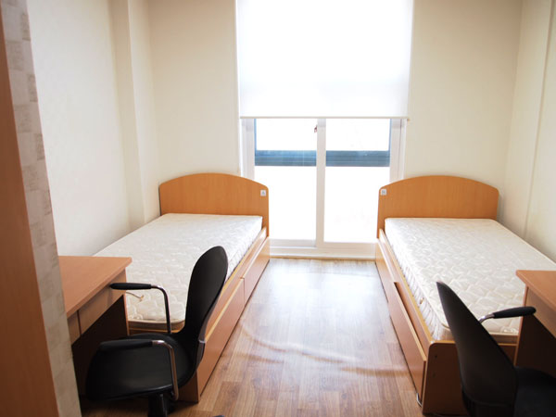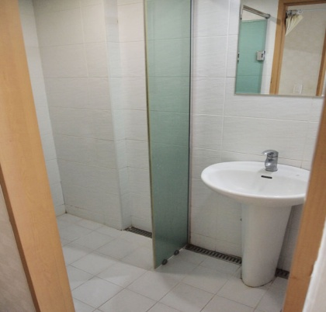
<Double Room>

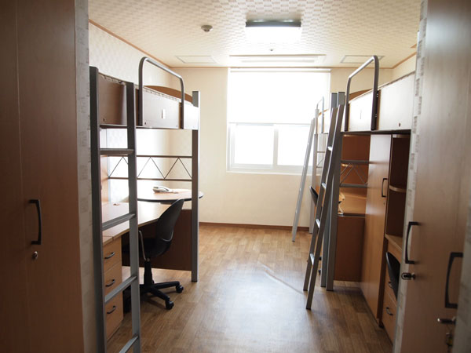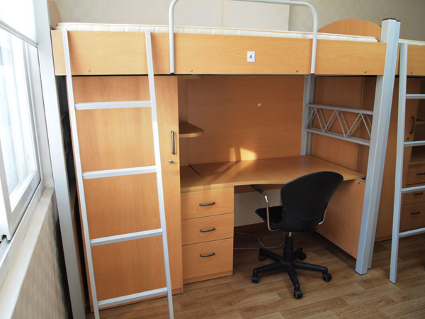
<Triple/Quad Room>

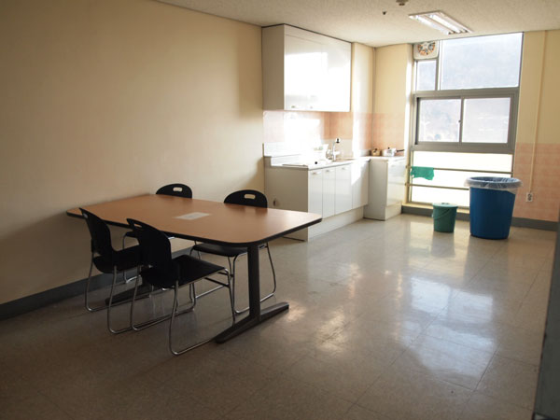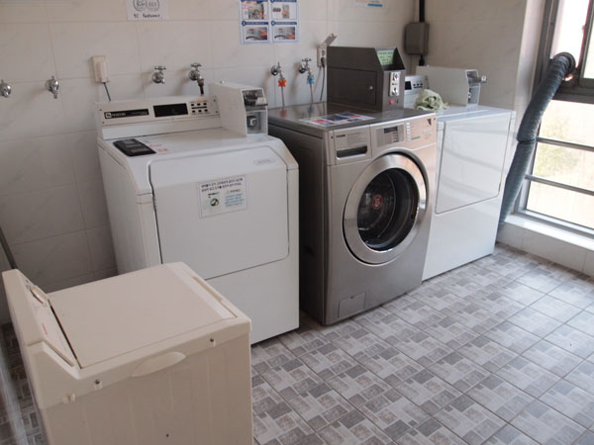
<Shared Kitchen> <Laundry Machine and Dryer>
* 1,000 Korean won per use

< Dormitory Rules>

1. Smoking/ bringing alcohol into the dormitory is strictly not
allowed. If caught, the penalty is expulsion.
2. Wearing shoes/slippers is not allowed inside the rooms.
3. Touching other student’s items is strictly forbidden.
4. Students cannot move to other room without informing the dormitory office in advance.
5. Violence or any forms of harassments will not be entertained.
6. Dormitory closes from 1 ~ 5 am, students cannot come in or leave during this time.
7. It’s strictly not allowed to visit other students room past 11 am at night or anything else that interferes with other students study or rest time.
8. Bringing or using dangerous electric appliances in the room is not allowed.
9. It is students’ responsibility to keep their room clean at all times. An inspection will be carried out at least once a month.
10. Always clean the dining room after using it.
11. Always check important notices on the notice board in each floor.
12. Cooking in the room is strictly PROHIBITED
13. Please Refer to Dormitory Rules
※ For more information, consult the notice board on each floor.

5. Other Information

★ Supermarket/Store/Mart

1) Bokjoeng Mart (복정할인마트)

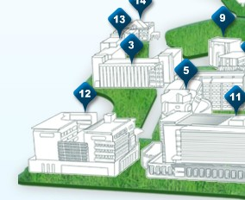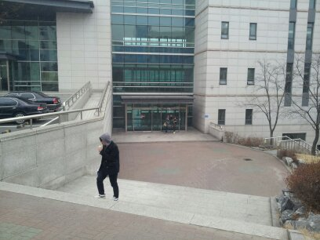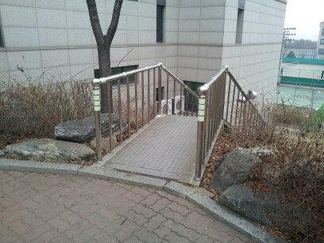

On the right side of building #12, is a small set of steps, pictured above. Go down the steps and head towards the main road. When you reach the main road, turn right and go straight for about 2minutes or so.

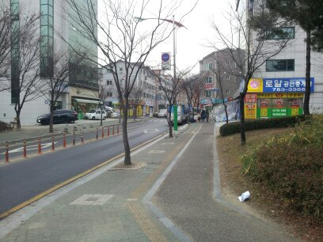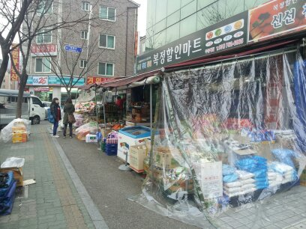
When you see the road like the one on the picture on the left, go straight for about 30m and you will see the mart, pictured on the right side.

2) Daiso (다이소) – Discounted Store

Working Hour: 9:30 ~ 22:00
How to get there:
Gachon Univ. Station (가천대역) Exit 3.


3) E-Mart (이마트) – Large Discounted Supermarket
Working Hour: 10:00 ~ 22:00
How to get there:
- Subway: From Gachon Univ. Station (가천대역) to Taepyoung Stattion (태평역)
Exit 3. Go straight up to E-Mart.(It takes around 15 min.on foot)



